5/21/2013 2:32 PM

Family Search Electronic Books DB Migration

Currently Family Search book scanning process is managed using two Access databases. One DB in Family History Library and the other in Orem. This work will involve combining both databases into one master network accessible database. This will be hosted in a Family Search Oracle database. In the future the design should allow for more scan centers to track scanning that is sent to Orem.

Moving the Tracking Form DB from Access to Oracle will involve several steps. First is to move the existing Access tables, views, and supporting objects from Access to Oracle. Next we will make updates to the current database schema. This will be done directly in Oracle using database scripts. Part of this work will involve merging both FHL and Orem Tracking Form schema into Oracle. There are some issues with inconsistent data due to the single table Access schema for books. An example of this is the site field is plain text and may contain multiple spellings of a site: Orem, OREM, FHL, Family History Library, etc. The new database design will address these types of data inconsistencies by enforcing a single spelling of an entry. Once the tables and views are complete, then we will migrate the actual production data from Access tables to Oracle tables. At the time of production data migration, we will deploy the new book tracking GUI software. This will replace the Access forms currently being used. Application details will follow later in a separate doc.

# MIGRATE SCHEMA

The Family Search book scanning database is currently in Microsoft Access. We will move it to an Oracle database.

1. Capture tables and views from Access. I will use Oracle SQL Developer to accomplish this. (via tools->migration->access exporter) From this tool, I generate a script which contains SQL that creates all of the tables, views, and supporting database objects.
2. Update tables SQL with new requirements to add more data integrity to the design.

**Existing Tables**:

Books

Compression_Entry

Jp_Update_titles

Number_of_Images_Entry

PDF_Archiving_Copy1_Entry

PDF_Archiving_Copy2_Entry

Scan_Date_Entry

Site_TN_Report

Switchboard_Items

TF_Loading_entry

TF_Notes

TF_Received_images_entry

TF_Released_entry

Tiff_Archiving_Copy1_Entry

Tiff_Archiving_Copy2_Entry

# Books table changes:

This list shows how the Orem and FHL Books tables will merge into the Master Books table.

|  |  |  |
| --- | --- | --- |
| **Orem Books (old in Access)**  TN  -  Title  Author  Call #  Priority Item  Withdrawn  Digital Copy Only  Media Type  Metadata Complete  Batch Class  Language  Remarks from SLc about book  Remarks about book  -  Scanned by  ***-***  ***-***  ***-***  Location  ***-***  Scan Complete Date  ***-***  ***-***  ***-***  ***-***  ***-***  # of pages  Files Received by Orem  Image Audit  IA Start Date  IA Complete Date  Imported by  Imported Date  Kofaxed by  Kofax Start date  PDF Ready  Date Released  Compression Code  Loaded by  Date Loaded  Collection  DNP  ***-***  TN Change History  PDF_Orem_Archived Date  PDF_Orem_Drive Serial #  PDF_Orem_Drive Name  PDF_Copy2_Archived Date  PDF_Copy2_Drive Serial #  PDF_Copy2_Drive Name  Tiff_Orem_Archived Date  Tiff_Orem_Drive Serial #  Tiff_Orem_Drive Name  Tiff_Copy2_Archived Date  Tiff_Copy2_Drive Serial #  Tiff_Copy2_Drive Name  PDF Sent to Load  Site  URL  PID  Pages Online | **Master Book (new in Oracle)**  TN  Secondary_Identifier  Title  Author  Call_#  Priority_Item  Withdrawn  Digital_Copy_Only  Media_Type (add FK)  Metadata_Complete  Batch_Class  Language  *Remarks_from_Scan_Center*  Remarks_about_book  Requesting_location  *Scanned_by (add FK)*  *Scan_Operator*  *Scan_Machine_id*  *Scan_Metadata_Complete*  Location  *Scan_Start_Date*  Scan_Complete_Date  *Scan_Image_Auditor*  *Scan_IA_Start_Date*  *Scan_IA_Complete_Date(future use)*  *Files_Sent_to_Orem*  *Scan_Num_of_Pages*  *Num_of_pages*  Files_Received_by_Orem  Image_Audit  IA_Start_Date  IA_Complete_Date  Imported_by  Imported_Date  Kofaxed_by  Kofax_Start_date  PDF_Ready  Date_Released  Compression_Code  Loaded_by  Date_Loaded  Collection  DNP  *DNP deleted off line*  TN_Change_History  PDF_Orem_Archived_Date  PDF_Orem_Drive_Serial_#  PDF_Orem_Drive_Name  PDF_Copy2_Archived_Date  PDF_Copy2_Drive_Serial_#  PDF_Copy2_Drive_Name  Tiff_Orem_Archived_Date  Tiff_Orem_Drive_Serial_#  Tiff_Orem_Drive_Name  Tiff_Copy2_Archived_Date  Tiff_Copy2_Drive_Serial_#  Tiff_Copy2_Drive_Name  PDF_Sent_to_Load  Site (add FK)  URL  PID  Pages_Online | **FHL.Books (old in Access)**  TN  -  Title  Author  Call #  ***-***  ***-***  ***-***  ***-***  ***-***  *Batch Class (if Orem null)*  ~~Foreign Language~~ (not used)  *Remarks about book*  ***-***  *-*  *“FHL” (hardcode text)*  *Scanned by*  *Machine #*  *Metadata Complete*  ***-***  *ScanDate*  -  *FHL Image Audit*  *FHL IA Date*  ***-***  Files Sent to Orem  # of pages  ***-***  ***-***  ***-***  ***-***  ***-***  ***-***  ***-***  ***-***  ***-***  ***-***  ***-***  ***-***  ***-***  ***-***  ***-***  DNP  DNP deleted off line  ***-***  ***-***  ***-***  ***-***  ***-***  ***-***  ***-***  ***-***  ***-***  ***-***  ***-***  ***-***  ***-***  ***-***  Site(not used)  URL  ***-***  ***-*** |

## Metadata table

Next we have the metadata from OLIB/FHL which we will merge into the tracking form Book table somehow. The plan is to keep metadata in a separate table at first in order to avoid confusion if a book seems to be ready for scan/kofax, but then later we decide it is not or if cataloging finds errors they need to fix. Also this is the db source that kofax/limb/abbyy feeds off of. (This will be like creating a metadata batch and then later we release the batch to scanning center to scan). Once scan/kofax/publish is complete we can then delete the rows form the metadata table since they will be preserved in the tracking form. (future kofax/limb/abbyy changes will only require metadata table updates as well) Also there is the concept of possible duplicate books already scanned that cataloging may not know about. A separate table will allow cataloging to do some duplicate book checking prior to releasing book to be scanned.

Currently Cathy sends Rose of Sharon an xls file with metadata (fields on left side of chart below). Rose of Sharon manipulates this data and imports it into both kofax sql server and tracking from db. In the future, the plan is to have Cathy directly put the data into the web-app. Then when the books are ready to be SCANNED (happens before processing in orem) then someone (FHL or scansite?) will click a move-metadata-for-scanning button to move the metadata into the tracking form table and be ready for scanning. Later when books are ready to be kofaxed (ie tiffs ready), Rose of Sharon will click another button to copy metadata into kofax sqlserver db.

When clicking the two buttons above on the web-app, we need a way for Rose Of Sharon to override values when propagating data from metadata table to TF table. (ie allow priority item to be “T/F”, dates, archive drive, etc – currently Rose of Sharon makes these decisions in her merged xls file)

Question: are we missing any metadata?

(note this has been updated so that all (mostly) of Cathy’s data are now in the tf Book table.)

|  |  |  |
| --- | --- | --- |
| **XLS from Cathy (ALL these to sqlserver db – ROS currenly does)**  Fhtitleno  Title  Authors  Subjects  Fhcallno  Fhfilmno  Summary  Fhdgsno  -  -  -  -  -  -  language  -  -  -  Scanning Location  -  -  -  -  -  -  -  -  -  -  Pages  -  -  -  -  -  -  -  -  -  -  -  -  -  -  -  -  -  -  -  -  -  -  -  -  -  -  -  -  -  -  -  - | **Master Book (new in Oracle)**  TN  Title  Author  -  Call_#  -  -  -  Priority_Item  Withdrawn  Digital_Copy_Only  Media_Type (add FK)  Metadata_Complete  Batch_Class  Language  *Remarks_from_Scan_Center*  Remarks_about_book  Requesting_location  *Scanned_by (add FK)*  *Scan_Operator*  *Scan_Machine_id*  *Scan_Metadata_Complete*  Location  *Scan_Start_Date*  Scan_Complete_Date  *Scan_Image_Auditor*  *Scan_IA_Start_Date*  *Scan_IA_Complete_Date(future use)*  *Files_Sent_to_Orem*  *Scan_Num_of_Pages*  *Num_of_pages*  Files_Received_by_Orem  Image_Audit  IA_Start_Date  IA_Complete_Date  Imported_by  Imported_Date  Kofaxed_by  Kofax_Start_date  PDF_Ready  Date_Released  Compression_Code  Loaded_by  Date_Loaded  Collection  DNP  *DNP deleted off line*  TN_Change_History  PDF_Orem_Archived_Date  PDF_Orem_Drive_Serial_#  PDF_Orem_Drive_Name  PDF_Copy2_Archived_Date  PDF_Copy2_Drive_Serial_#  PDF_Copy2_Drive_Name  Tiff_Orem_Archived_Date  Tiff_Orem_Drive_Serial_#  Tiff_Orem_Drive_Name  Tiff_Copy2_Archived_Date  Tiff_Copy2_Drive_Serial_#  Tiff_Copy2_Drive_Name  PDF_Sent_to_Load  Site (add FK)  URL  PID  Pages_Online | **Processing required (ROS currently does)**  -  -  -  -  -  -  -  -  “F”  “F”  “F”  “Book”  now  calc based on first letter in lang & PD?  -  -  -  -  Also show on scan page (ie ‘FHL’)  -  -  -  ’02 Tiffs’  -  ?add to scan page if not already  -  -  -  -  (scan or titlecheck operator)  -  ?(when metadata complete)  -  -  -  -  -  -  -  -  -  -  -  -  -  -  -  -  ? Allow input when process  ?Allow input when process  ?Allow input when process  -  -  -  -  -  -  -  -  -  -  ?‘Orem’  -  -  - |

# TF_Notes table changes:

After books rows have been migrated then TF_Notes rows will be migrated. TF_Notes columns:

ID PK

TN PK FK

Status

Problem_Text

Problem_Date

Problem_Initials

Solution_Text

Solution_Date

Solution_initials

Primary key will be TN+ID. ID will start at 1 for each TN and increase by 1 for each new problem for a particular TN. TN will be a foreign key referring to Books.TN.

Migrating data from FHL TF_Notes will only consist of inserting new TNs that do not already exist in the Orem TF_Notes table.

# New tables and values (removing bad data, duplicates, or spelling variations):

**Site** - and foreign key in Book.site and Book.Scanned_by

Values:

(See updates below for values)

**Status** – and foreign key in TF_notes.status

Values:

"Problem"

"Solution Found"

"Problem Fixed"

"Notes"

~~“+++-`”~~  (book 183106 in fhl has this strange status. Probably just delete the row form TF_notes)

**Media** – and foreign key in Book.media_type

Values:

~~Books~~

~~BOOK~~

~~BOOk~~

~~Book24~~

~~0~~

Book

~~Book [Film #10056?]~~

Books [Film #10056]

~~Books [Film #10056]~~

Books [Film #10057]

Books [Film #1058]

Books [Film #10737]

Books [Film #10738]

Books [Film #10739]

Books [Film #1584]

Books [Film #10736]

~~Books [Film #10736]~~

~~Books [Film #10737]~~

Books [Film #1585]

~~Books [Film #1585]~~

CD ROM

~~CP_BK_FHL_English~~

~~FOREIGN~~ (some other colum??? Jeri part of language. Ask david why foreign is here~~)~~

~~GMRV~~

~~Mesa~~

Serial

~~Serial * (some stange numbers at end of line)~~

~~Serials~~

~~SERIAL~~

~~serial~~

~~FW Serial~~

Film

Fiche

**Updates**:

Various data type changes need to be made to tables in order to be compatible with Oracle.

1. Update queries/update/deletes SQL to be compatible with Oracle. (This will be more of an Application bit of work, not DB as fare a migration goes) (see Book Scan Milestones doc for list of queries)

1. A new Oracle sequence will be added for inserts into the TF_Notes table: TF_Notes_ID_SEQ

*12/12/2012 – I don’t think we will even need this since notes are unique via TN. Also date is stored. I don’t see any use of it in Access forms other than auto generated when inserted. --Paul

MIGRATE DATA

I will use a tool called “TOAD for Oracle” to do the data migration from the tables in Access to Oracle. Preliminary runs using TOAD on existing rows in the Access tables have run successfully. When we are ready to go to production, I will re-run TOAD to capture the latest data and move it into Oracle. Also there will be a few data updates that I will run. (ie Change “OREM” “Orem” in site columns for example)

# Below is the step by step process to move actual data (run night before production goes live)

A MIGRATE SCHEMA

1 capture tables and views from Access in Oracle SQL Developer tools->migration->access exporter (output is xml file)

2.run migration tool in SQL Developer tools->migration->migrate (Source offline is xml file above. Target is offline script)

(I ended up just generating the sql script and then removing userid etc and alter script as needed)

Notice in Migration Projects sub-tab....

3. right click and select Migration project doc. (this shows how many tables/views/etc and errors via html pages generated)

4. fix datatypes, views, etc

5 Create new tables (lookup tables) (foreign keys in Book added later after data inserted)

***steps 1-5 are done and saved in ebook_create.sql and ebook_views.sql.

6 Run in ebook_create.sql and ebook_views.sql scripts (I run them in SQL Developer)

(create script first tries to delete tables, so if running for first time you will get errors. Just re-run to verify all works with no errors)

7 Run elder_kern_metadata.sql

B MIGRATE DATA - use TOAD (direct from Access file to script/insert)

1. First copy two TF Access apps to local c:\ebooks... ~~and \fhl~~ or some folder on your pc

(update – just using orem’s db since we will run in tandem with old system and migrate daily when books get published)

2. NEW- Create query(s) in Access to only display books that are published: book-import1 (ie not in process or Iarchive since some dates are not set, but they are loaded, so just get all iarchive books) (have to create more than 1 since Toad runs out of memory and so do it in 4 steps:

**SELECT \***

**FROM Books**

**WHERE ((((Books.[Site])<>'Orem')) OR (((Books.[date loaded]) Is Not Null) AND ((Books.[pdf ready]) Is Not Null) AND ((Books.[date released]) Is Not Null))) and tn < '2';**

**SELECT \***

**FROM Books**

**WHERE ((((Books.[Site])<>'Orem')) OR (((Books.[date loaded]) Is Not Null) AND ((Books.[pdf ready]) Is Not Null) AND ((Books.[date released]) Is Not Null))) and tn > '2' and tn < '6';**

**SELECT \***

**FROM Books**

**WHERE ((((Books.[Site])<>'Orem')) OR (((Books.[date loaded]) Is Not Null) AND ((Books.[pdf ready]) Is Not Null) AND ((Books.[date released]) Is Not Null))) and tn > '6' ;**

2. Then try import using TOAD. Look for any issues (ie top few rows in import table report. TOAD seemed to match duplicates on Title and merge both TNs together, when confused)

In toad go to database->schemabrowser

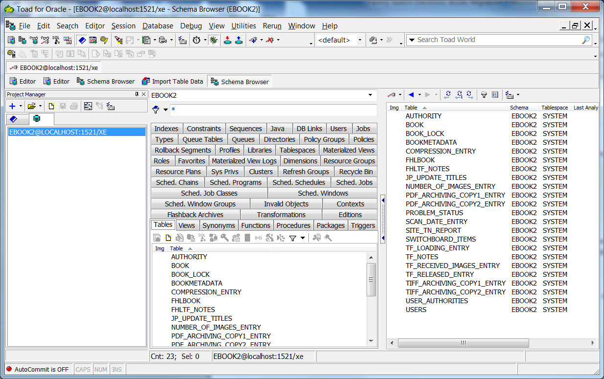

Then rightclick on table (ie book or tf_notes) and select import data.

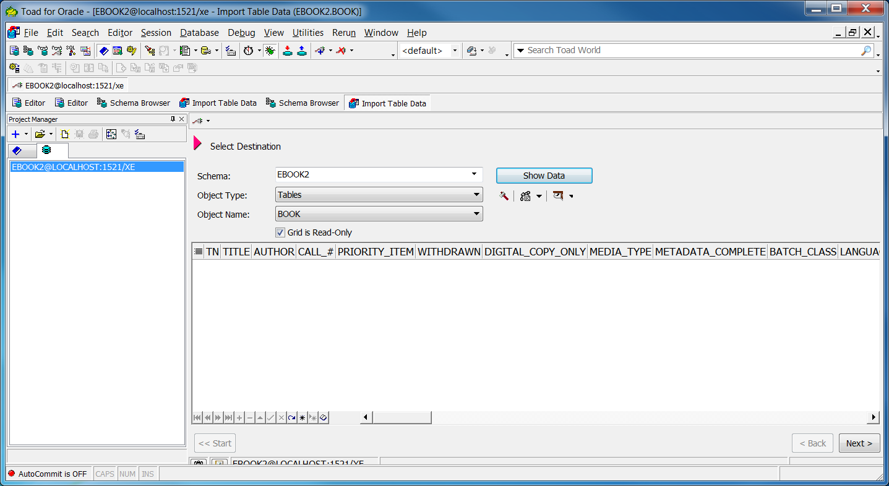

Select Access DB file and select matching table name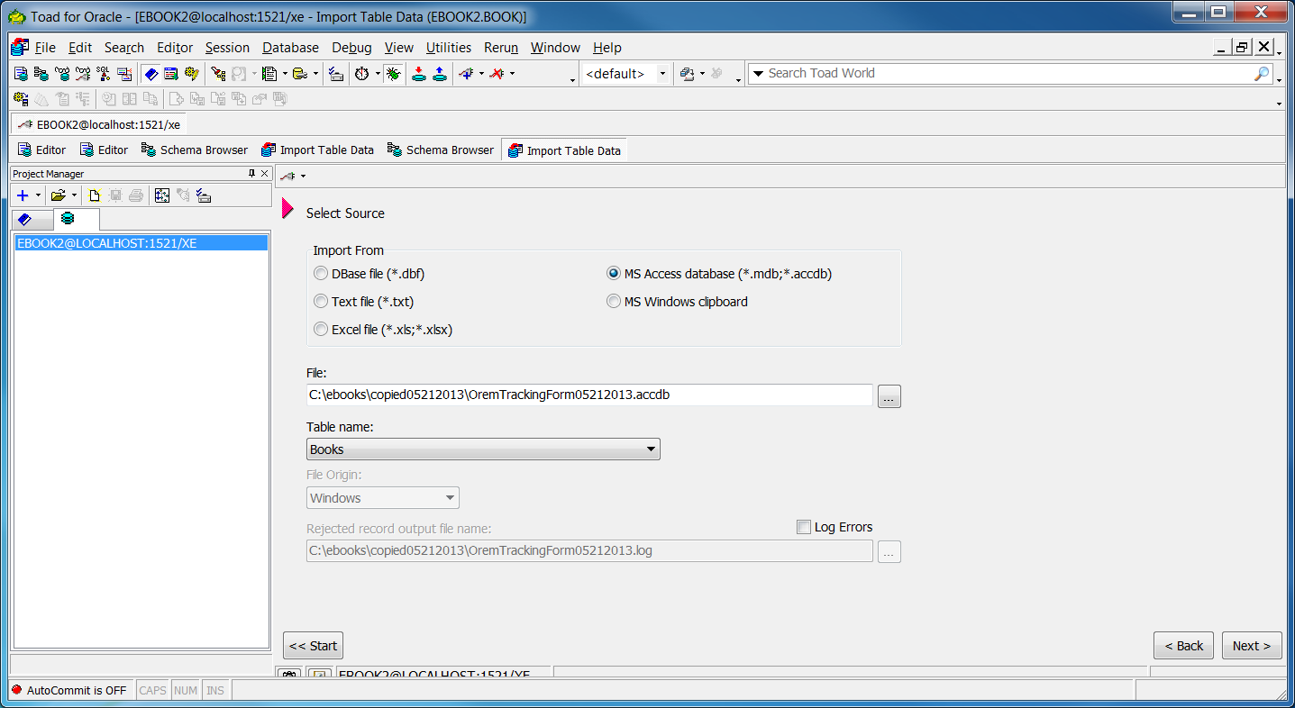

Put in a large number for last row that is larger than the number of rows in book table. Start at 2 if you want to skip the 0000 row.

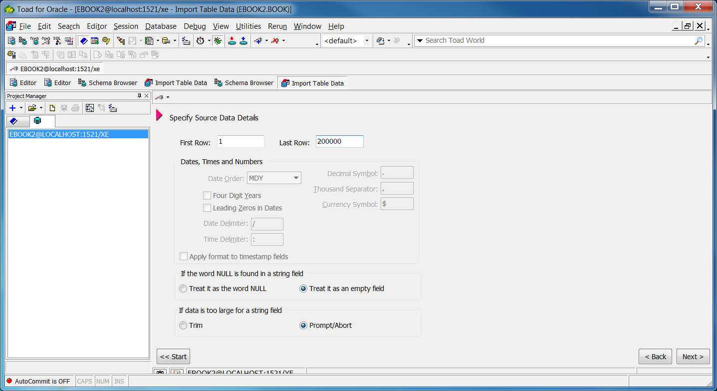

Then next.

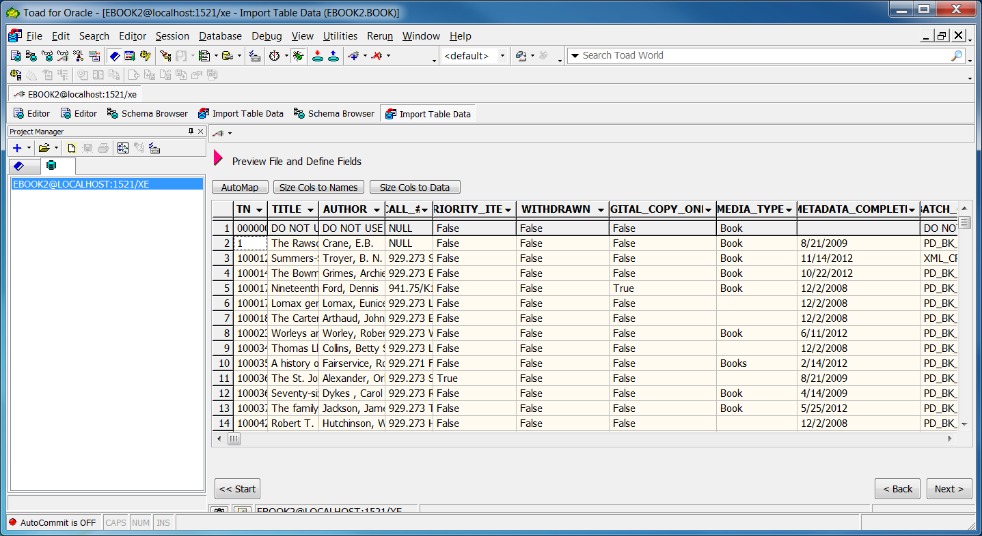

Verify that columns match: update: “remarks from slc about book”, Num_of_pages.

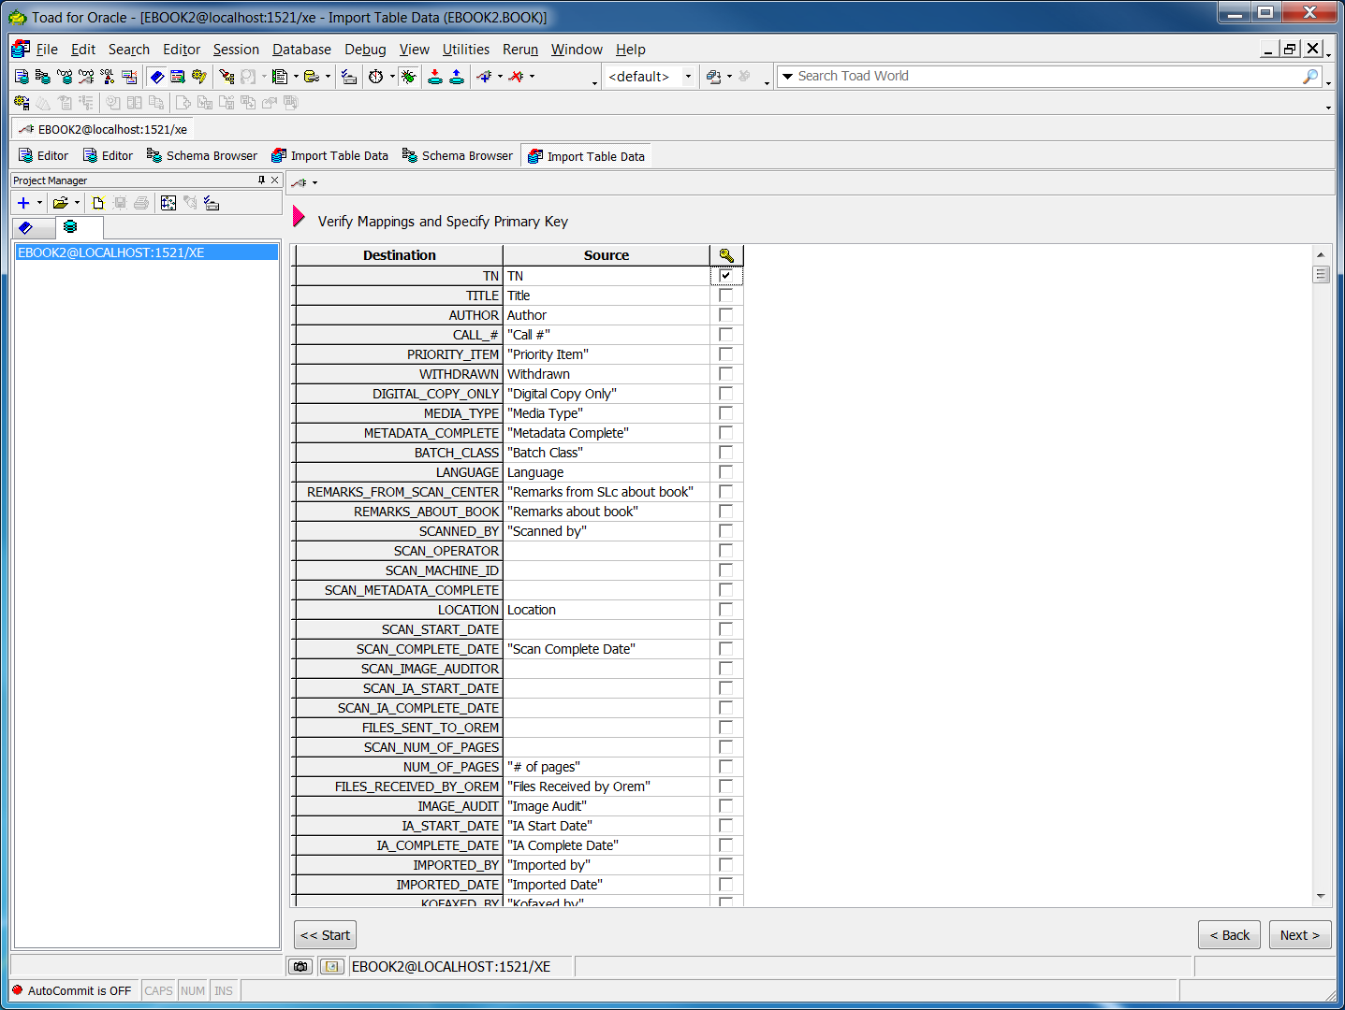

Next

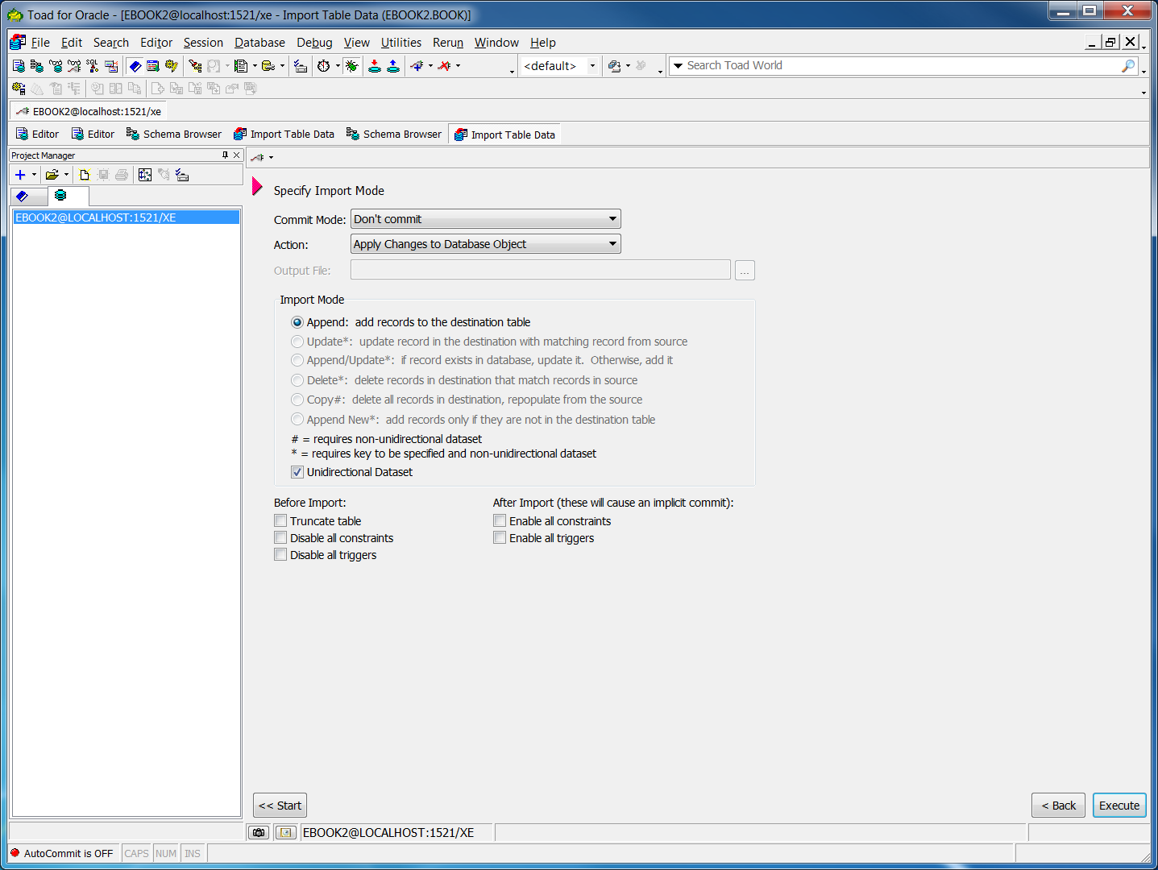

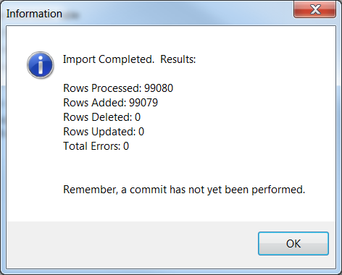

Next

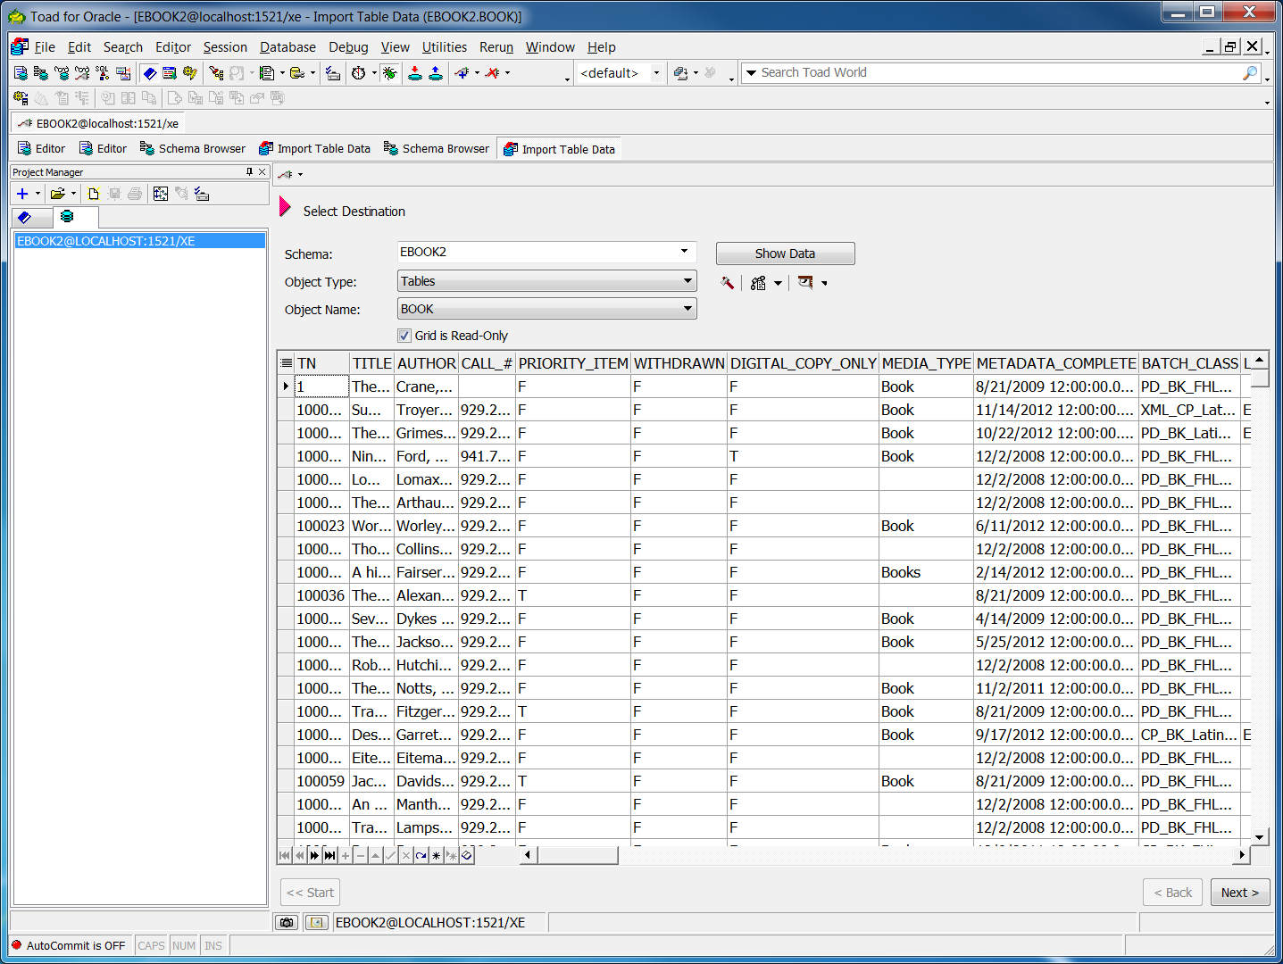

Do a sanity check on a few rows of data.

Do commit in menu: Session->commit.

~~3. (Not needed now since running in tandom with old. ROS deletes notes when closed) Import Books and TF_Notes~~

~~*when import, verify columns match. (ie Check num_of_pages etc using this doc) (Import will skip FK constraint breaks in TF_Notes, which is what I want so as to filter out old notes. Since there are a few (8 or so) tf_notes rows that do not match to a book. And 2 that have a bad status)~~

~~4. . (Not needed now since running in tandom with old.) Import FHL into fhlBooks and fhlTF_Notes (!!verify #_of_pages selected)~~

~~6. (done in access tf) delete tn 00000000000 from Orem if imported~~

~~7. look into renaming tn=1 in fhl with 134351 (as is in orem and olib) (DONE)~~

~~8. –(run SQL for New tables and lookup data updates below) todo after insert, update rows Site, Scanned_by, Status, Media columns in Books table to match lookup table values (capitalizations, extra spaces, etc)~~

~~9. --(not needed) todo change minvalue before run to match last tb_notes row added~~

~~10. --todo add Table Site and fk from books, etc to site -then retest stats-kofaxed to make sure dups are gone (OREM AND Orem)~~

11. Also get data with Toad from Elder Kern’s tblSearchedBackups table from metadata Accesss db. “K:\Kern\EHD Search Backend” is the file. Copy it to my local pc and copy tables to local.

12. run updates and inserts below

# SQL for New tables and lookup data updates

DROP TABLE Site CASCADE CONSTRAINTS;

CREATE TABLE Site (

ID VARCHAR2(255 CHAR) primary key,

Publish_name varchar(511 CHAR),

Location VARCHAR2(510 CHAR),

contact VARCHAR2(255 CHAR),

number_of_operators VARCHAR2(3 CHAR),

is_fhc CHAR(1) DEFAULT 'F' check (is_fhc IN ('T', 'F')),

is_partner_institution CHAR(1) DEFAULT 'F' check ( is_partner_institution IN ('T', 'F')),

is_scan_site CHAR(1) DEFAULT 'F' check ( is_scan_site IN ('T', 'F')),

is_process_Site CHAR(1) DEFAULT 'F' check ( is_process_Site IN ('T', 'F')),

is_physical_book_site CHAR(1) DEFAULT 'F' check ( is_physical_book_site IN ('T', 'F'))

);

--site goals

DROP TABLE Site_goal CASCADE CONSTRAINTS;

CREATE TABLE Site_goal (

site VARCHAR2(255 CHAR) ,

year VARCHAR2(255 CHAR),

goal_images_yearly NUMBER(11,0),

CONSTRAINT site_goal_Key PRIMARY KEY

(

site, year

)

ENABLE

);

ALTER TABLE Site_goal add constraint fk_site_goals foreign key(site) references site(ID);

insert into site col(id, publish_name, is_partner_institution, is_scan_site ) values('Allen County Public Library (ACPL)', 'Allen County Public Library; http://www.acpl.lib.in.us/', 'T', 'T');

insert into site col(id, publish_name, is_fhc, is_scan_site) values('Blackfoot Idaho Family History Center',

'Blackfoot Idaho Family History Center; http://www.familysearch.org/', 'T', 'T');

insert into site col(id, publish_name, is_fhc, is_scan_site) values('Brigham City FamilySearch Center' , 'Brigham City FamilySearch Center; http://familysearch.org/', 'T', 'T');

insert into site col(id, is_partner_institution, is_scan_site) values('BYU-Hawaii', 'T', 'T');

insert into site col(id, publish_name, is_partner_institution, is_scan_site) values('BYU Idaho', 'Brigham Young University Idaho David O. McKay Library; http://www.lib.byui.edu/', 'T', 'T');

insert into site col(id, is_partner_institution, is_scan_site) values('Church History Library', 'T', 'F');

insert into site col(id, is_partner_institution, is_scan_site) values('Clayton Library', 'T', 'T');

insert into site col(id, publish_name, is_fhc, is_scan_site) values('Family History Library', 'Family History Library, FamilySearch International; http://www.familysearch.org/', 'T', 'T');

insert into site col(id, is_partner_institution, is_scan_site) values('GMRV', 'T', 'T');

insert into site col(id, is_partner_institution, is_scan_site) values('Harold B. Lee Library (HBLL)', 'T', 'T');

insert into site col(id, publish_name, is_partner_institution, is_scan_site) values('Houston Metropolitan Research Center- Texas Room', 'Houston Public Library - Clayton Library; http://www.houstonlibrary.org/', 'T', 'T');

insert into site col(id, publish_name, is_partner_institution, is_scan_site) values('Houston Public Library - Clayton Library', 'Houston Public Library - Houston Metropolitan Research Center - Texas Room; http://www.houstonlibrary.org/', 'T', 'T');

insert into site col(id, is_partner_institution, is_scan_site) values('Internet Archives (IA)', 'T', 'T');

insert into site col(id, is_fhc, is_scan_site) values('Los Angeles FHC (Orem)', 'T', 'T');

insert into site col(id, publish_name, is_fhc, is_scan_site) values('Las Vegas Nevada FamilySearch Library', 'Las Vegas Nevada FamilySearch Library; https://www.familysearch.org/learn/wiki/en/Las_Vegas_Nevada_FSL', 'T', 'T');

insert into site col(id, publish_name, is_fhc, is_scan_site) values('Mesa Region FHC', 'Mesa FamilySearch Library, FamilySearch International; http://www.familysearch.org/' ,'T', 'T');

insert into site col(id, is_partner_institution, is_scan_site) values('Midwest Genealogy Center', 'T', 'T');

~~insert into site col(id, publish_name, is_partner_institution, is_scan_site) values('Mid-Continent Public Library', 'Mid-Continent Public Library, http://www.mcpl.lib.mo.us/', 'T', 'T');~~

insert into site col(id, publish_name, is_fhc, is_scan_site) values('Ogden Regional FHC', 'Ogden FamilySearch Library, FamilySearch International; http://www.familysearch.org/', 'T', 'T');

insert into site col(id, is_fhc, is_scan_site) values('Orange California Family History Center', 'T', 'T');

insert into site col(id, is_process_site ) values('Orem Digital Processing Center', 'T');

insert into site col(id, is_fhc, is_scan_site) values('Preservation Imaging Center', 'T', 'T');

insert into site col(id, publish_name, is_fhc, is_scan_site) values('Pocatello Idaho FamilySearch Library', 'Pocatello FamilySearch Library, FamilySearch International; http://www.familysearch.org/', 'T', 'T');

insert into site col(id, publish_name, is_fhc, is_scan_site) values('American Falls Idaho Family History Center', 'American Falls Idaho Family History Center; http://familysearch.org/', 'T', 'F');

insert into site col(id, publish_name, is_fhc, is_scan_site) values('Sacramento California Regional Family History Center', 'Sacramento California Regional Family History Center; http://www.familyhistorycenter.info/index.html', 'T', 'T');

insert into site col(id, publish_name, is_fhc, is_scan_site) values('St. George FamilySearch Library', 'St. George FamilySearch Library; FamilySearch International; http://www.familysearch.org/', 'T', 'T');

INSERT INTO Site (ID) values ( 'DNP');

INSERT INTO Site (ID, publish_name, is_partner_institution, is_scan_site) values ('Denver Public Library', 'Denver Public Library; http://history.denverlibrary.org/', 'T', 'T');

INSERT INTO Site (ID, publish_name, is_fhc, is_scan_site) values ('Donation to Family Search', 'Donation to Family Search; http://www.familysearch.org/', 'T', 'T');

INSERT INTO Site (ID, is_partner_institution, is_scan_site) values ('Proquest', 'T', 'T');

INSERT INTO Site (ID, publish_name, is_fhc, is_scan_site) values ('Logan Family History Center', 'Logan Family History Center, FamilySearch International; http://www.familysearch.org/', 'T', 'T');

INSERT INTO Site (ID, publish_name, is_fhc, is_scan_site) values ('Eagar Arizona Stake', 'Eagar Arizona Stake Family History Center; FamilySearch International; http://www.familysearch.org/' ,'T', 'T');

!!!!!!!!!!!!!!!!!!!!!!!!be sure to save script as utf8 or get bad chars like Korean Chinese. BUT there is then the problem with diaretics that do not show up correctly. To get those save notepad script as ANSI… So plan is to later query title like ‘%�%’ and then reextract titles and authors !!!!!!!!!!!!!!!!!!!!!!

-fix scanned_by and owning_inst concatinations

(run one at a time since scanned_by is updated on second pair up dates)

UPDATE Book set owning_institution = 'American Falls Idaho Family History Center' where upper(scanned_by) = upper('Poc.-American Falls');

UPDATE Book set scanned_by = 'Pocatello Idaho FamilySearch Library' where upper(scanned_by) = upper('Poc.-American Falls');

UPDATE Book set owning_institution = 'St. George FamilySearch Library' where upper(scanned_by) = upper('OG -St. George');

UPDATE Book set scanned_by = 'Ogden Regional FHC' where upper(scanned_by) = upper('OG -St. George');

UPDATE Book set owning_institution = 'Family History Library' where upper( scanned_by) =upper( 'MC - FHL');

UPDATE Book set scanned_by = 'Midwest Genealogy Center' where upper( scanned_by) = upper('MC - FHL');

UPDATE Book set owning_institution = 'Eagar Arizona Stake' where upper( scanned_by) = upper('MESA-EAGAR');

UPDATE Book set scanned_by = 'Mesa Region FHC' where upper( scanned_by )=upper( 'MESA-EAGAR');

UPDATE Book set owning_institution = 'Family History Library' where upper( scanned_by) =upper( 'MIDCONT.-FHL');

UPDATE Book set scanned_by = 'Mid-Continent Public Library' where upper( scanned_by) = upper('MIDCONT.-FHL');

UPDATE Book set owning_institution = 'Family History Library' where upper( scanned_by) = upper('MIDCONT-FHL');

UPDATE Book set scanned_by = 'Mid-Continent Public Library' where upper( scanned_by) = upper('MIDCONT-FHL');

UPDATE Book set owning_institution = 'St. George FamilySearch Library' where upper( scanned_by) =upper( 'OG-ST.. GEORGE');

UPDATE Book set scanned_by = 'Ogden Regional FHC' where upper( scanned_by )= upper('OG-ST.. GEORGE');

UPDATE Book set owning_institution = 'Family History Library' where upper( scanned_by) = upper('OGDEN - FHL');

UPDATE Book set scanned_by = 'Ogden Regional FHC' where upper( scanned_by) = upper('OGDEN - FHL');

UPDATE Book set owning_institution = 'Family History Library' where upper( scanned_by )= upper('OGDEN- FHL');

UPDATE Book set scanned_by = 'Ogden Regional FHC' where upper( scanned_by) = upper('OGDEN- FHL');

UPDATE Book set owning_institution = 'Family History Library' where upper( scanned_by) = upper('OGDEN_FHL');

UPDATE Book set scanned_by = 'Ogden Regional FHC' where upper( scanned_by )=upper( 'OGDEN_FHL');

UPDATE Book set owning_institution = 'Brigham City FamilySearch Center' where upper( scanned_by) = upper('OGDEN-BC');

UPDATE Book set scanned_by = 'Ogden Regional FHC' where upper( scanned_by) =upper( 'OGDEN-BC');

UPDATE Book set owning_institution = 'Family History Library' where upper( scanned_by) = upper('OGDEN-FHL');

UPDATE Book set scanned_by = 'Ogden Regional FHC' where upper( scanned_by) = upper('OGDEN-FHL');

UPDATE Book set owning_institution = 'St. George FamilySearch Library' where upper( scanned_by) = upper('OG-ST. GEORGE');

UPDATE Book set scanned_by = 'Ogden Regional FHC' where upper( scanned_by) =upper( 'OG-ST. GEORGE');

UPDATE Book set owning_institution = 'Blackfoot Idaho Family History Center' where upper( scanned_by) = upper('POC-BLACKFOOT');

UPDATE Book set scanned_by = 'Pocatello Idaho FamilySearch Library' where upper( scanned_by )= upper('POC-BLACKFOOT');

UPDATE Book set owning_institution = 'Logan Family History Center' where upper( scanned_by) =upper( 'Ogden Regional FHC'); --all logan books owned are scanned by ogden

|  |
| --- |
|  |
|  |

-next update sites to match in site table

UPDATE Book set Site = 'Family History Library' where Site = 'FHL';

UPDATE Book set Site = 'Family History Library' where Site = 'FHl';

UPDATE Book set Site = 'Allen County Public Library (ACPL)' where Site = 'Fort Wayne';

UPDATE Book set Site = 'Allen County Public Library (ACPL)' where Site = 'FW';

UPDATE Book set Site = 'Allen County Public Library (ACPL)' where Site = 'FW ';

UPDATE Book set Site = 'Allen County Public Library (ACPL)' where Site = 'ACPL';

UPDATE Book set Site = 'BYU Idaho' where Site = 'BYU-I';

UPDATE Book set Site = 'BYU Idaho' where Site = 'BYUI';

UPDATE Book set Site = 'Clayton Library' where Site = 'Clayton';

UPDATE Book set Site = 'Houston Metropolitan Research Center- Texas Room' where Site = 'HOUSTON';

UPDATE Book set Site = 'Houston Metropolitan Research Center- Texas Room' where Site = 'Houston';

UPDATE Book set Site = 'Houston Metropolitan Research Center- Texas Room' where Site = 'TxRoom';

UPDATE Book set Site = 'Houston Metropolitan Research Center- Texas Room' where Site = 'Texas Room';

UPDATE Book set Site = 'Las Vegas Nevada FamilySearch Library' where Site = 'Las Vegas';

UPDATE Book set Site = 'Logan Family History Center' where Site = 'Logan';

UPDATE Book set Site = 'Midwest Genealogy Center' where site = 'Mid-Continent Public Library';

UPDATE Book set Site = 'Midwest Genealogy Center' where site = 'Midwest-FHL';

UPDATE Book set Site = 'Midwest Genealogy Center' where site = 'MC-FHL';

UPDATE Book set Site = 'Midwest Genealogy Center' where site = 'Midcont. -FHL';

UPDATE Book set Site = 'Midwest Genealogy Center' where Site = 'MC - FHL';

UPDATE Book set Site = 'Midwest Genealogy Center' where Site = 'Independence_MC';

UPDATE Book set Site = 'Midwest Genealogy Center' where Site = 'INDEPENDENCE';

UPDATE Book set Site = 'Midwest Genealogy Center' where Site = 'MidContinent';

UPDATE Book set Site = 'Midwest Genealogy Center' where Site = 'Midcontinent';

UPDATE Book set Site = 'Midwest Genealogy Center' where Site = 'Independence';

UPDATE Book set Site = 'Midwest Genealogy Center' where Site = 'Indepence';

UPDATE Book set Site = 'Midwest Genealogy Center' where Site like '%Midwest Gen%';

UPDATE Book set Site = 'Orem Digital Processing Center' where Site = 'OREM';

UPDATE Book set Site = 'Orem Digital Processing Center' where Site = 'Orem';

UPDATE Book set Site = 'Orem Digital Processing Center' where Site = 'OREm';

UPDATE Book set Site = 'Orem Digital Processing Center' where Site = 'orem';

UPDATE Book set Site = 'Harold B. Lee Library (HBLL)' where Site = 'byu';

UPDATE Book set Site = 'Harold B. Lee Library (HBLL)' where Site = 'Byu';

UPDATE Book set Site = 'Harold B. Lee Library (HBLL)' where Site = 'BYU';

UPDATE Book set Site = 'Internet Archives (IA)' where Site = 'Iarchive';

UPDATE Book set Site = 'Denver Public Library' where Site = 'denver';

UPDATE Book set Site = 'Denver Public Library' where Site = 'Denver';

UPDATE Book set Site = 'Donated' where Site = 'NGS Donations';

UPDATE Book set Site = 'Donated' where Site = 'PP-Donations';

UPDATE Book set Site = 'Donation to Family Search' where Site = 'Donated';

UPDATE Book set Site = 'Donation to Family Search' where Site = 'donated';

UPDATE Book set Site = 'Donation to Family Search' where Site = 'Donation';

UPDATE Book set Site = 'Donation to Family Search' where Site = 'Donations';

UPDATE Book set Site = null where Site = 'Fiche';

UPDATE Book set Site = null where Site = 'Film';

UPDATE Book set Site = null where Site = 'FILM';

UPDATE Book set Site = null where Site = 'DO NOT USE';

UPDATE Book set Site = 'Mesa Region FHC' where Site = 'Mesa';

UPDATE Book set Site = 'Mesa Region FHC' where Site = 'MESA';

UPDATE Book set Site = 'Eagar Arizona Stake' where Site = 'Mesa-Eagar';

UPDATE Book set Site = 'Family History Library' where Site = 'SLC';

UPDATE Book set Site = 'Ogden Regional FHC' where Site = 'Ogden_FHL' ;

UPDATE Book set Site = 'Ogden Regional FHC' where Site = 'Ogden - FHL';

UPDATE Book set Site = 'Ogden Regional FHC' where Site = 'Ogden- FHL';

UPDATE Book set Site = 'Ogden Regional FHC' where Site = 'Ogden_SLC';

UPDATE Book set Site = 'Ogden Regional FHC' where Site = 'Ogden-FHL';

UPDATE Book set Site = 'Ogden Regional FHC' where Site = 'Ogden';

UPDATE Book set Site = 'Ogden Regional FHC' where Site = 'Ogden-BC';

UPDATE Book set Site = 'Pocatello Idaho FamilySearch Library' where Site = 'Pocatello';

UPDATE Book set Site = 'GMRV' where Site = 'FHL/GMRV';

UPDATE Book set Site = 'GMRV' where Site = 'GMRV/FHL';

UPDATE Book set Site = 'GMRV' where Site = 'FHL-GMRV';

UPDATE Book set Site = 'Sacramento California Regional Family History Center' where Site = 'Sacramento';

UPDATE Book set Site = 'St. George FamilySearch Library' where Site = 'St. George';

UPDATE Book set Site = 'St. George FamilySearch Library' where Site = 'OG -St. George';

update book set scanned_by = 'Ogden Utah FamilySearch Library' where scanned_by = 'Ogden Regional FHC';

update book set scanned_by = 'Mesa Arizona FamilySearch Library' where scanned_by = 'Mesa Region FHC';

update book set scanned_by = 'Sacramento California FamilySearch Library' where scanned_by = 'Sacramento California Regional Family History Center';

*Do same owning_institution, Requesting_Location, and Scanned_by book

~~*Do same Requesting_Location and Scanned_by bookmetadata~~

-Get new sites (scanned_by has many it seems) and add to lists above:

select distinct(scanned_by) from book where scanned_by not in (select id from site)

ALTER TABLE Book add constraint fk_site_books foreign key(Site) references SITE(ID);

ALTER TABLE Book add constraint fk_site_books2 foreign key(Scanned_by) references SITE(ID);

ALTER TABLE Book add constraint fk_site_books3 foreign key(Requesting_Location) references SITE(ID);

ALTER TABLE Book add constraint fk_site_books4 foreign key(owning_institution) references SITE(ID);

ALTER TABLE USERS add constraint fk_USERS foreign key(PRIMARY_LOCATION ) references SITE(ID);

ALTER TABLE bookmetadata add constraint fk_site_id foreign key(Scanning_Location) references site(ID) ;

ALTER TABLE bookmetadata add constraint fk_reqloc_id foreign key(Requesting_Location) references site(ID) ;

DROP TABLE Languages CASCADE CONSTRAINTS;

CREATE TABLE Languages (

ID VARCHAR2(255 CHAR) primary key,

Publish_name VARCHAR2(255 CHAR)

);

INSERT INTO Languages values ('Afrikaans', 'Afrikaans;afr;af');

INSERT INTO Languages values ('Czech', 'Czech;cze;cz');

INSERT INTO Languages values ('Chinese', 'Chinese;chi;ch');

INSERT INTO Languages values ('Danish', 'Danish;dan;da');

INSERT INTO Languages values ('Dutch', 'Dutch;dut;du');

INSERT INTO Languages values ('English', 'English;eng;en');

INSERT INTO Languages values ('French', 'French;fre;fr');

INSERT INTO Languages values ('German', 'German;ger;ge');

INSERT INTO Languages values ('Icelandic', 'Icelandic;ice;ic');

INSERT INTO Languages values ('Italian', 'Italian;ita;it');

INSERT INTO Languages values ('Latin', 'Latin;lat;la');

INSERT INTO Languages values ('Norwegian-Bokmal', 'Norwegian-Bokmal;nor;no');

INSERT INTO Languages values ('Norwegian-Nynorsk', 'Norwegian-Nynorsk;nor;no');

INSERT INTO Languages values ('Norwegian', 'Norwegian;nor;no');

INSERT INTO Languages values ('Portuguese', 'Portuguese;por;po');

INSERT INTO Languages values ('Spanish', 'Spanish;spa;sp');

INSERT INTO Languages values ('Russian', 'Russian;rus;ru');

INSERT INTO Languages values ('Romanian’, 'Romanian;rom;ro');

INSERT INTO Languages values ('Swedish', 'Swedish;swe;sw');

INSERT INTO Languages values ('Welsh', 'Welsh;wel;we');

INSERT INTO Languages values ('Czech ', 'Czech;cze;cz');

INSERT INTO Languages values ('Hungarian', 'Hungarian;hun;hu');

INSERT INTO Languages values ('Polish', 'Polish;pol;po');

INSERT INTO Languages values ('Slovic', 'Slovic;slo;sl');

INSERT INTO Languages values ('Samoan', 'Samoan;sam;sa');

INSERT INTO Languages values ('Tongan', 'Tongan;son;to');

INSERT INTO Languages values ('Korean', 'Korean;kor;ko');

INSERT INTO Languages values ('Croatian (Roman)', 'Croatian;cro;cr');

INSERT INTO Languages values ('Serbo-Croatian (Cyrillic)', 'Serbo-Croation;ser;se');

INSERT INTO Languages values ('Croatian', 'Croatian;cro;cr');

INSERT INTO Languages values ('Greek, Modern', 'Greek, Modern;gre;gr');

INSERT INTO Languages values ('Japanese', 'Japanese;jap;ja');

INSERT INTO Languages values ('Tahitian', 'Tahitian;tah;ta');

INSERT INTO Languages values ('Indonesian', 'Indonesian;ind;in');

UPDATE BOOK set language = 'English' where language LIKE '%ngli%';

UPDATE BOOK set language = 'English' where language LIKE '%Eng%';

UPDATE BOOK set language = 'English' where language LIKE '%ENGLI%';

UPDATE BOOK set language = 'French' where language LIKE '%rench%';

UPDATE BOOK set language = 'Slovic' where language like '%lovia%';

UPDATE BOOK set language = 'Slovic' where language like '%loveni%';

UPDATE BOOK set language = 'Slovic' where language like '%lovak%';

UPDATE BOOK set language = 'Norwegian' where language like '%orweg%' and language != 'Norwegian-Bokmal' and language != 'Norwegian-Nynorsk';

UPDATE BOOK set language = null where language = 'NO-OCR';

UPDATE BOOK set language = null where language = 'NO_OCR';

UPDATE BOOK set language = null where language = 'No OCR';

ALTER TABLE Book add constraint fk_lang_books foreign key(language) references LANGUAGES(ID);

ALTER TABLE Bookmetadata add constraint fk_lang_bookmd foreign key(language) references LANGUAGES(ID);

ALTER TABLE iaBookmetadata add constraint fk_lang_iabookmd foreign key(language) references LANGUAGES(ID);

DROP TABLE Media CASCADE CONSTRAINTS;

CREATE TABLE Media (

ID VARCHAR2(255 CHAR) primary key

);

INSERT INTO Media values ('Book');

INSERT INTO Media values ('Books [Film #10056]');

INSERT INTO Media values ('Books [Film #10057]');

INSERT INTO Media values ('Books [Film #1058]');

INSERT INTO Media values ('Books [Film #10737]');

INSERT INTO Media values ('Books [Film #10738]');

INSERT INTO Media values ('Books [Film #10739]');

INSERT INTO Media values ('Books [Film #1584]');

INSERT INTO Media values ('Books [Film #10736]');

INSERT INTO Media values ('Books [Film #1585]');

INSERT INTO Media values ('CD ROM');

INSERT INTO Media values ('Serial');

INSERT INTO Media values ('Film');

INSERT INTO Media values ('Fiche');

UPDATE Book set Media_type = 'Book' where Media_type = 'Books';

UPDATE Book set Media_type = 'Book' where Media_type = 'Book320';

UPDATE Book set Media_type = 'Book' where Media_type = 'Book24';

UPDATE Book set Media_type = 'Book' where Media_type = 'BOOK';

UPDATE Book set Media_type = 'Book' where Media_type = 'BOOk';

UPDATE Book set Media_type = null where Media_type = '0';

UPDATE Book set Media_type = 'Books [Film #10056]' where Media_type = 'Book [Film #10056?]';

UPDATE Book set Media_type = 'Books [Film #10056]' where Media_type = 'Books [Film #10056]';

UPDATE Book set Media_type = 'Books [Film #10737]' where Media_type = 'Books [Film #10737]';

UPDATE Book set Media_type = 'Books [Film #10736]' where Media_type = 'Books [Film #10736]';

UPDATE Book set Media_type = 'Books [Film #1585]' where Media_type = 'Books [Film #1585]';

UPDATE Book set Media_type = 'Book' where Media_type = 'CP_BK_FHL_English';

UPDATE Book set Media_type = null where Media_type = 'FOREIGN';

UPDATE Book set Media_type = null where Media_type = 'GMRV';

UPDATE Book set Media_type = null where Media_type = 'Mesa';

UPDATE Book set Media_type = 'Serial' where Media_type like '%Serial%';

UPDATE Book set Media_type = 'Serial' where Media_type like '%SERIAL%';

UPDATE Book set Media_type = 'Serial' where Media_type like '%serial%';

ALTER TABLE Book add constraint fk_media_books foreign key(media_type) references MEDIA(ID);

Update book set publication_type = 'Serial' where Media_type = 'Serial';

Update book set publication_type = 'Book' where publication_type is null;

***updated nov 2013 to put in flag scan_complete for missionaries

select count(*) from book where date_loaded is not null and scan_complete_date is null;

1 update book set scan_complete_date = files_received_by_orem where scan_complete_date is null

2 update book set scan_complete_date = date_loaded where scan_complete_date is null

!!!!update DNP “Copied from Old TF 12-18-2013”

DROP TABLE Status CASCADE CONSTRAINTS;

CREATE TABLE Status (

ID VARCHAR2(255 CHAR) primary key

);

INSERT INTO Status values ('Problem');

INSERT INTO Status values ('Solution Found');

INSERT INTO Status values ('Problem Fixed');

INSERT INTO Status values ('Notes');

~~(tf_notes are not needed since running in tandem with old)~~

~~DELETE FROM TF_Notes where status = '+++-`';~~

~~DELETE FROM fhlTF_Notes where status = '+++-`';~~

~~UPDATE fhlTF_Notes set status = 'Problem' where status is not null and status not in ( 'Problem', 'Solution Found', 'Problem Fixed', 'Notes');~~

ALTER TABLE TF_Notes add constraint fk_notes_status foreign key(status) references STATUS(ID);

~~ALTER TABLE fhlTF_Notes add constraint fk_fhlnotes_status foreign key(status) references STATUS(ID);~~

# Update SQL (only run after TOAD import on Access BOOKS and TF_NOTES (and into temp FHL tables))

~~UPDATE 1:~~

~~UPDATE book a~~

~~set a.remarks_from_scan_center = (select b.remarks_about_book from fhlbook b where b.tn = a.tn ),~~

~~a.scan_operator = (select b.scanned_by from fhlbook b where b.tn = a.tn ),~~

~~a.scan_machine_id = (select b.machine_# from fhlbook b where b.tn = a.tn ),~~

~~a.scan_metadata_complete = (select b.metadata_complete from fhlbook b where b.tn = a.tn ),~~

~~a.scan_start_date = (select b.scandate from fhlbook b where b.tn = a.tn ),~~

~~a.scan_num_of_pages = (select b.num_of_pages from fhlbook b where b.tn = a.tn ),~~

~~a.scan_image_auditor = (select b.fhl_image_audit from fhlbook b where b.tn = a.tn ),~~

~~a.scan_ia_start_date = (select b.fhl_ia_date from fhlbook b where b.tn = a.tn )~~

~~where exists (select * from fhlbook c where c.tn = a.tn and a.scanned_by = 'FHL')~~

~~UPDATE 2:~~

~~UPDATE book a~~

~~set a.batch_class = (select b.batch_class from fhlbook b where b.tn = a.tn )~~

~~where exists (select * from fhlbook c where c.tn = a.tn and a.scanned_by = 'FHL' and a.batch_class = null)~~

~~-this turned out to be 0 updates after all~~

# Update file_sent_to_orem on any book already in orem(hack so not displayed in scan queue) ~~(only run before doing insert from fhlBook)~~

(run in 3 steps of precedence: scan_complet_date, files_received_by_orem, dummydate)

update book set files_sent_to_orem = scan_complete_date where files_sent_to_orem is null;

-all should be updated

update book set files_sent_to_orem = files_received_by_orem where files_sent_to_orem is null;

-null scan_complete updated

update book set files_sent_to_orem = to_date('11/11/1111', 'MM/DD/YYYY') where files_sent_to_orem is null;

--any remaining

# ~~Insert SQL (run after TOAD imports)~~

~~INSERT INTO book (tn,~~

~~title,~~

~~author,~~

~~call_#,~~

~~Batch_Class,~~

~~Remarks_from_Scan_Center,~~

~~Scanned_by,~~

~~Scan_Operator,~~

~~Scan_Machine_id,~~

~~Scan_Metadata_Complete,~~

~~Scan_Start_Date,~~

~~Scan_Image_Auditor,~~

~~Scan_IA_Start_Date,~~

~~Files_Sent_to_Orem,~~

~~Scan_Num_of_Pages,~~

~~DNP,~~

~~DNP_deleted_off_line,~~

~~Site,~~

~~URL) select TN,~~

~~Title,~~

~~Author,~~

~~Call_#,~~

~~Batch_Class,~~

~~Remarks_about_book,~~

~~'FHL',~~

~~Scanned_by,~~

~~Machine_#,~~

~~Metadata_Complete,~~

~~ScanDate,~~

~~FHL_Image_Audit,~~

~~FHL_IA_Date,~~

~~Files_Sent_to_Orem,~~

~~num_of_pages,~~

~~DNP,~~

~~DNP_deleted_off_line,~~

~~Site,~~

~~URL~~

~~from fhlbook where tn not in (select b.tn from book b);~~

# ~~Update BOOK files_sent_to_orem with dummy date – orphaned books (825 books or so were updated I think)~~

~~update book set files_sent_to_orem = to_date('01/01/80', 'MM/DD/YY') where date_released is null and files_received_by_orem is null and files_sent_to_orem is null and date_loaded is null and dnp is null and tn not in (select tn from fhlbooks)~~

~~Run to check for collisions and rename ids if so:~~

~~select * From fhltf_notes a, tf_notes b where a.tn = b.tn and a.id = b.id~~

~~INSERT INTO TF_Notes~~

~~(ID,~~

~~TN,~~

~~Status,~~

~~Problem_Text,~~

~~Problem_Date,~~

~~Problem_Initials,~~

~~Solution_Text,~~

~~Solution_Date,~~

~~Solution_initials)~~

~~select ID,~~

~~TN,~~

~~Status,~~

~~Problem_Text,~~

~~Problem_Date,~~

~~Problem_Initials,~~

~~Solution_Text,~~

~~Solution_Date,~~

~~Solution_initials from fhlTF_Notes;~~

~~Merging Orem and FHL Databases Notes(these are captured in the Book table changes chart above)~~

~~A Tracking Form database is used in both Orem and FHL in SLC. They are similar, but have many differences. The goal here is to combine them both into one master database that both sites can connect to at the same time.~~

**NOW, daily copy in newly date_loaded books query: (or maybe better to get loading summary xls from ROS:** Kserver/01 Admin/01 Reports/04 loaded online/ (each day’s total is shown on a tab)

**Query by date if needed:**

**SELECT \***

**FROM Books**

**WHERE [date loaded] > #2013-08-01#**

**And ([pdf ready] is not null and [date released] is not null)**

**ORDER BY [date loaded];**

**Oracle SELECT tn, to_char(date_loaded, 'yyyy/mm/dd')**

**FROM Book**

**WHERE to_char(date_loaded, 'yyyy/mm/dd') = '2013/10/06';**

(Note need to check for sites that have no entry in new Site table)

(A import into temp bookTemp table,

B run site updates and

C then run a copy of rows into Book table: insert into book (select * from booktemp)

If duplicates, then they have been re-processed (or Iarchive), so first delete those and then re-insert. Delete will be okay since overwriting anyway!

)

MISC info… FHL Book table:

All columns in FHL Book table map directly to Orem’s Book table except the following.

-skip Foreign_Language column – not used

-add Machine # to Orem’s Books table and rename to Scan_Machine_ID

-Metadata Complete add to Orem and rename as Scan_Metadata_Complete (Since Orem has a duplicate column that appears to have different dates)

-Batch Class - Is there a need to have a separate Scan_Batch_Class column? No. Same column can be used in both FHL and Orem. Orem will change value that fhl may add.

When migrating data, allow Orem’s batch_class values to override any values the are in fhl column if scanned by column is FHL.

-Scanned by (orem has values of “FHL” fhl column has missionary names as values) We will add column Scan_operator and put fhl.scanned_by values into Scan_operator if orem.scanned_by = ‘FHL’. (ie some books in the fhl db appear in Orem’s db, but have a non-fhl scanned_by value, so we will not update these.)

-When inserting new TNs from FHL that do not exist in Orem, use hardcoded text “FHL” for Scanned_by column.

-ScanDate in FHL seems to be start date. Copy to Orem table and rename to Scan_Start_Date. (since it has a Scan_Complete_Date already) ???but Scan_Complete_Date seems to be used for something else, but I do not see it accessed from any TF GUI…

-FHL Image Audit – copy to Orem and rename Scan_Image_Auditor (for future non-FHL scanning)

-FHL IA Date – copy and rename to Scan_IA_Start_Date

-Scan_IA_Complete_Date new column for future use

Notes…